***Wyndham Hill Co-op   
 Newsletter***

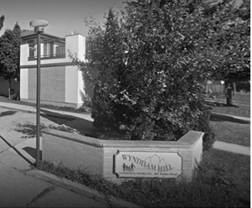

*February 2019*

Released February 19 2019

**Caring for your unit!**

.

If we have had a big snowfall and you see the plow here, go and move your car to the street so your parking spots can be cleaned, otherwise shovel your spot. The plow generally will not go within 2 feet of any parked car.   
This year the middle back 4 spots visitors parking (both sides) will be used for snow removal please do not park here.  
  
Reminder there is also no overnight parking on the street during a snow event. Overnight parking passes for visitor spots remain available from Joan in the office.  
  
**Reminder to salt and shovel your sidewalk, salt is available in the community center! If confused about where to shovel please ask Joan.**

**Know Your Unit Tip!**

**If toilet is flooding immediately turn off water to the toilet by turning this valve so it is all the way off and the toilet will not continue to overflow!  
Located near the floor on left hand side of the toilet!**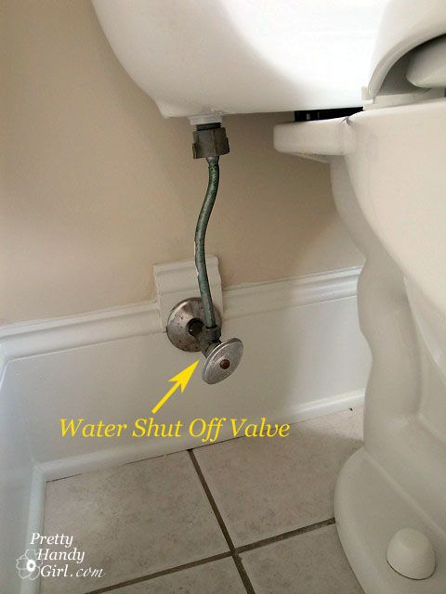

.  
As members, we like to keep our homes tidy and safe for our families. We want to remind you of some small things that can keep small maintenance issues down. Here 5 things you can do!

* Vacuum the exhaust ceiling fan in your bathroom to reduce buildup.
* After using soaps in the shower, run tap with very hot water after every use for a minute and/ or use Drano once a month to keep showers and tubs running well.
* Change litter and clean up after your pets in and around your unit. Improves hygiene and reduces floor damage. Keep litter away from water heater or will set of CO2 monitor on it and stop your hot water.
* Behind and under fridge and stoves to prevent fires.  Do not clutter the top of the fridge because it needs the airflow.   If you load it up, air cannot get to the back of the fridge.
* Putting soap in back of toilet water and letting soap sit in the bowl then run through the system with hot water helps prevent clogs.

**Park Snow Smart!**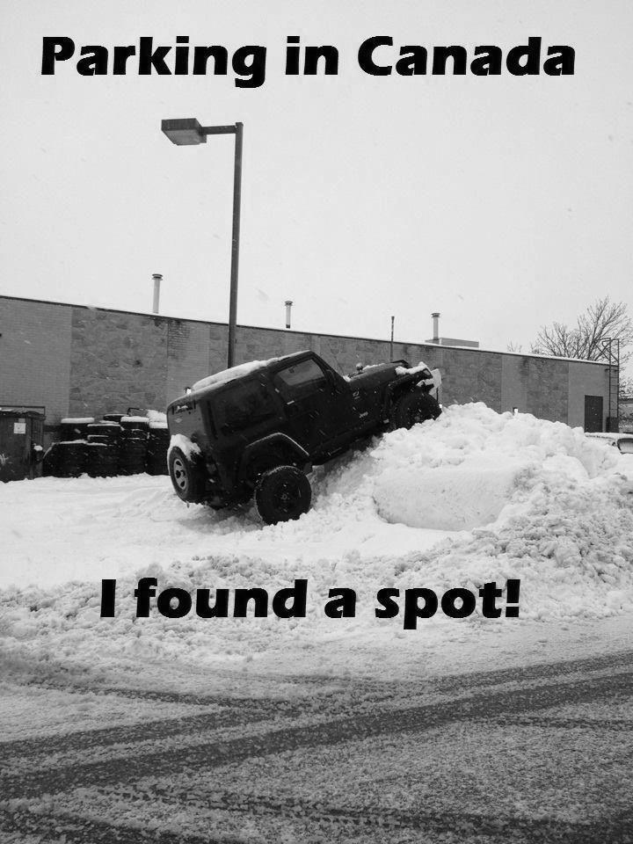



**Fire Safety Discussion**

**Updates from the Board**

To continue our fire safety discussion from last month there are a few more ways to help ensure your home is fire safe! (Check out the checklist)

* Keep one meter around your electrical panel free of clutter around your electrical panel!
* Know where your fire extinguisher is and have a fire exit plan.
* Check your smoke detector every time there is a time change
* Make sure all doors are clear of debris or clutter so they can fully open
* Make sure around front, patio and back doors that there is one meter clear and a safe path so you might be able to easily exit your unit.
* Clean around all appliances regularly because grease can build up and cause a fire.
* Avoid letting lint build up in your dryer and throw lint away, cleaning around washers and dryers helps prevent fire.
* Always pay attention to candles, don’t leave the room while they burn
* Keep flammable objects away from heat sources in your unit

At the Ag At

Thank you to everyone who attended the AGM! We had a great crowd of people and were very happy with the level of attendance. Keep showing up and being involved in your community because it just helps us further improve the community to be its best for all members.

Reminder to ask Joan to put you on the agenda or email if there is something you might like to see done or if you have ideas for around the coop. Always want to hear feedback from members to better serve our co-op!

There are several new members moving in and some members moving to different units. Please introduce yourself and be friendly to our new neighbours and get to know those new around you!

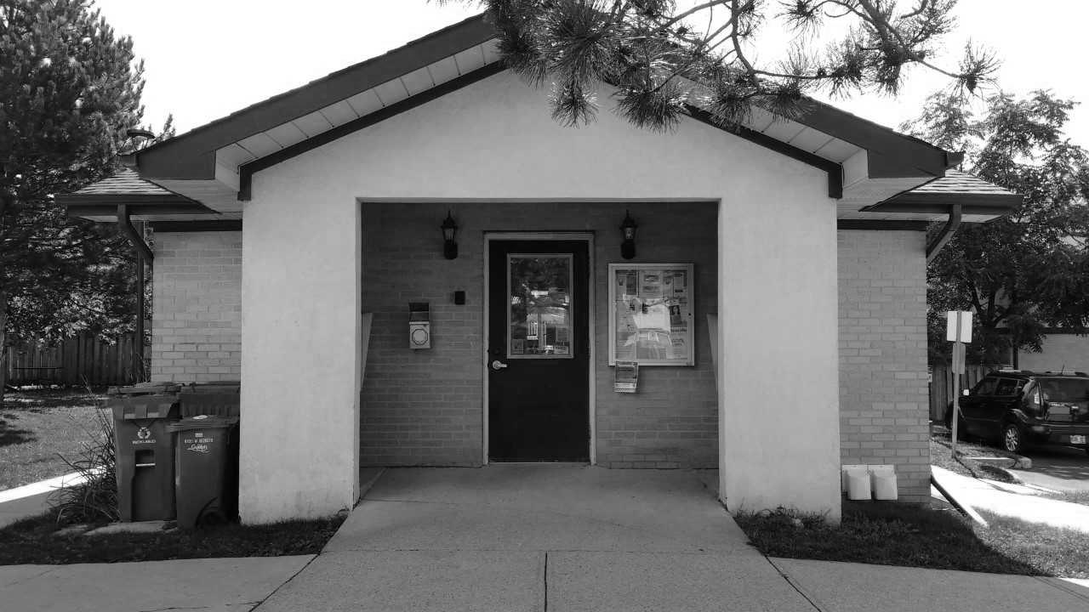

**Rent the Community Center for parties!**

**Only 10$ for members!   
The community center is a great space for your party! Please see Joan for information!**